Lab Assignment- 3.1
Experiment – Prompt Engineering Techniques
Budati Gayathri
2303A51717
Batch-11
Question 1: Zero-Shot Prompting (Palindrome Number Program)
Prompts: Generate a Python function that checks whether a given number is a palindrome.
Code:
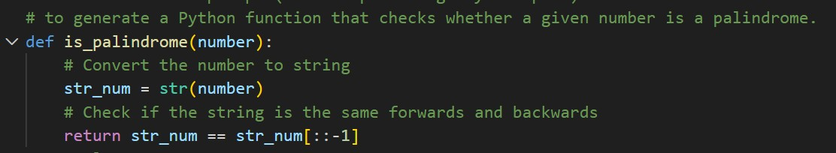
Output:
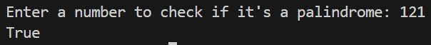
Explaination: This code determines whether a number entered by the user is a palindrome, which means it reads the same forwards and backwards. When the user inputs a number, the code first converts it to a string so that it can easily compare the sequence of digits. It then checks if this string is identical to its reverse. If they match, the function returns True, indicating the number is a palindrome; otherwise, it returns False. The result is printed out, letting the user know whether their number is a palindrome or not.
Question 2: One-Shot Prompting (Factorial Calculation)
Prompts: Generate a Python function to compute the factorial of a given number.
Code:
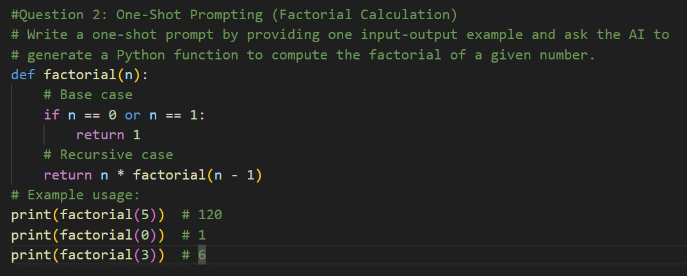
Output:
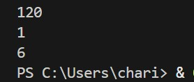
Explaination:This code defines a function to calculate the factorial of a given number using recursion. The factorial of a number (written as n!) is the product of all positive integers up to that number. For example, 5! = 5 × 4 × 3 × 2 × 1 = 120. The function checks if the input is 0 or 1, in which case it returns 1, since the factorial of both 0 and 1 is 1. The example usage shows how the function works for different inputs, printing the results for 5, 0, and 3.

Question 3: Few-Shot Prompting (Armstrong Number Check)
Prompts: Generating a Python function to check whether a given number is an Armstrong number.
Code:
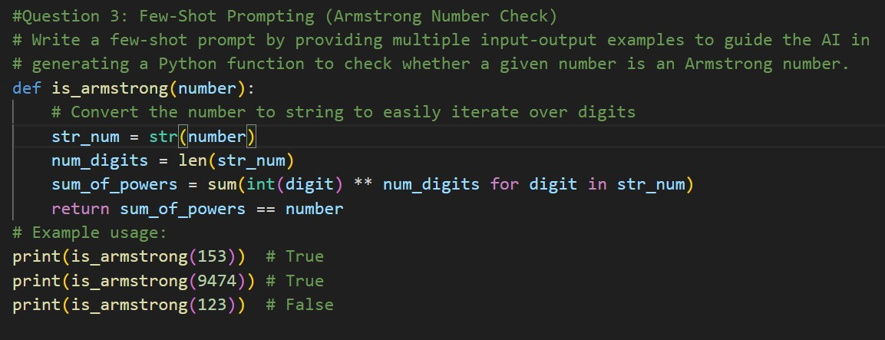
Output:
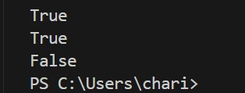
Explaination:This code defines a function to check if a number is an Armstrong number. An Armstrong number is a number that is equal to the sum of its own digits each raised to the power of the number of digits. The function works by first converting the number to a string so it can easily access each digit. It then calculates the number of digits and computes the sum of each digit raised to that power. If this sum matches the original number, the function returns True; otherwise, it returns False

Question 4: Context-Managed Prompting (Optimized Number Classification)
Prompts: Generate an optimized Python program that classifies a number as prime, composite, or neither.
Code:
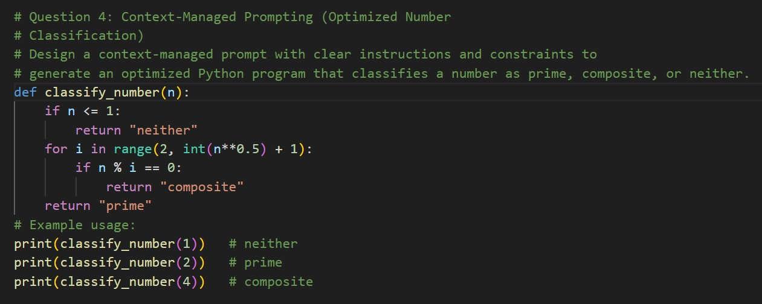
Output:
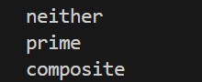
Explaination:This code defines a function that classifies a given number as "prime," "composite," or "neither." If the input number is less than or equal to 1, it returns "neither" because 0 and 1 are not considered prime or composite. For numbers greater than 1, it checks if the number is divisible by any integer from 2 up to the square root of the number. If it finds a divisor, the number is "composite".

Question 5: Zero-Shot Prompting (Perfect Number Check)
Prompts: Generate a Python function that checks whether a given number is a perfect number.
Code:
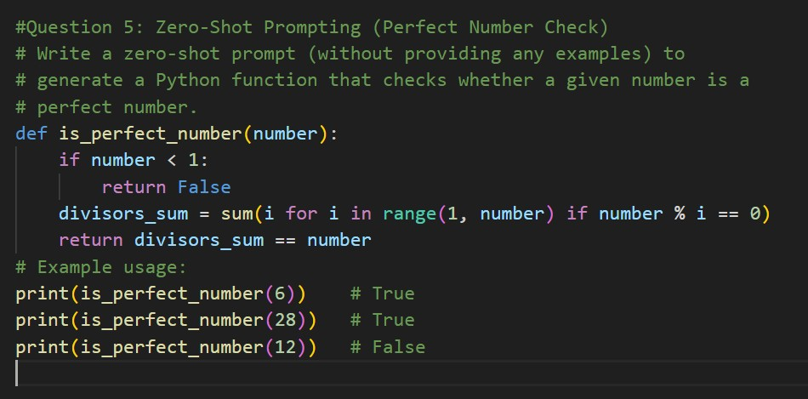
Output:
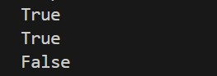
Explaination:This code defines a function to check if a number is a perfect number. A perfect number is a positive integer that is equal to the sum of all its proper divisors
(excluding itself). The function first checks if the number is less than 1, returning False since perfect numbers must be positive. It then calculates the sum of all divisors of the number from 1 up to (but not including) the number itself. If this sum equals the original number, the function returns True.

Question 6: Few-Shot Prompting (Even or Odd Classification with Validation) Prompts: Determines whether a given number is even or odd, including proper input validation.
Code:
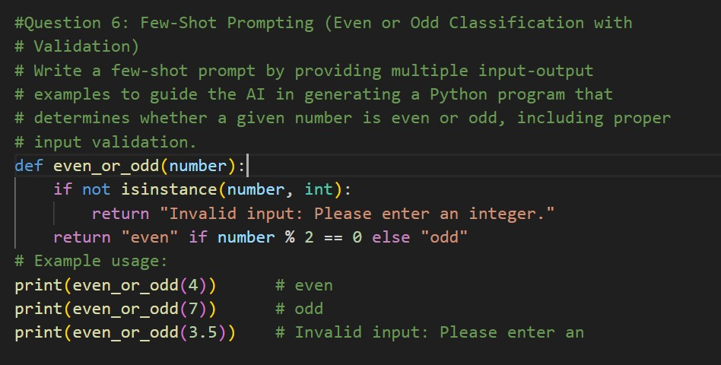
Output:
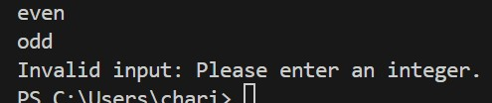
Explaination:This code defines a function that determines whether a given number is even or odd, with input validation. The function first checks if the input is an integer; if not, it returns a message asking for a valid integer. If the input is an integer, it checks if the number is divisible by 2. If it is, the function returns "even"; otherwise, it returns "odd."

